17. Perform Edge detection using Sobel Matrix along X axis

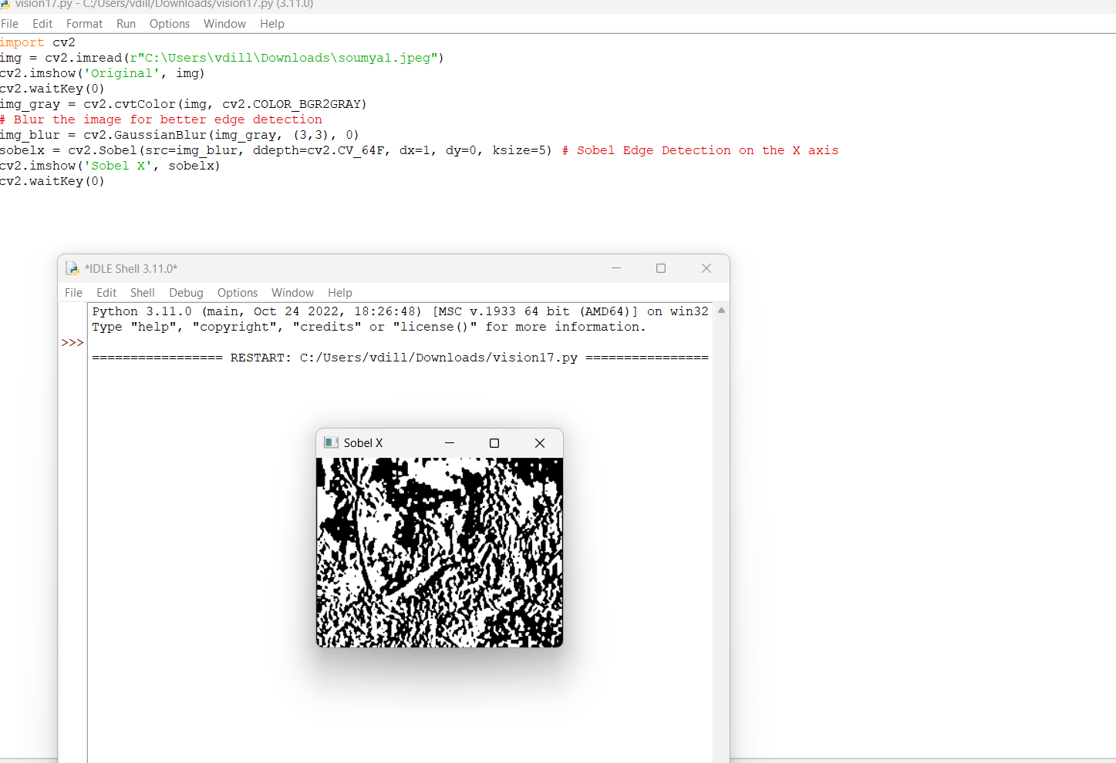

18. Perform Edge detection using Sobel Matrix along Y axis

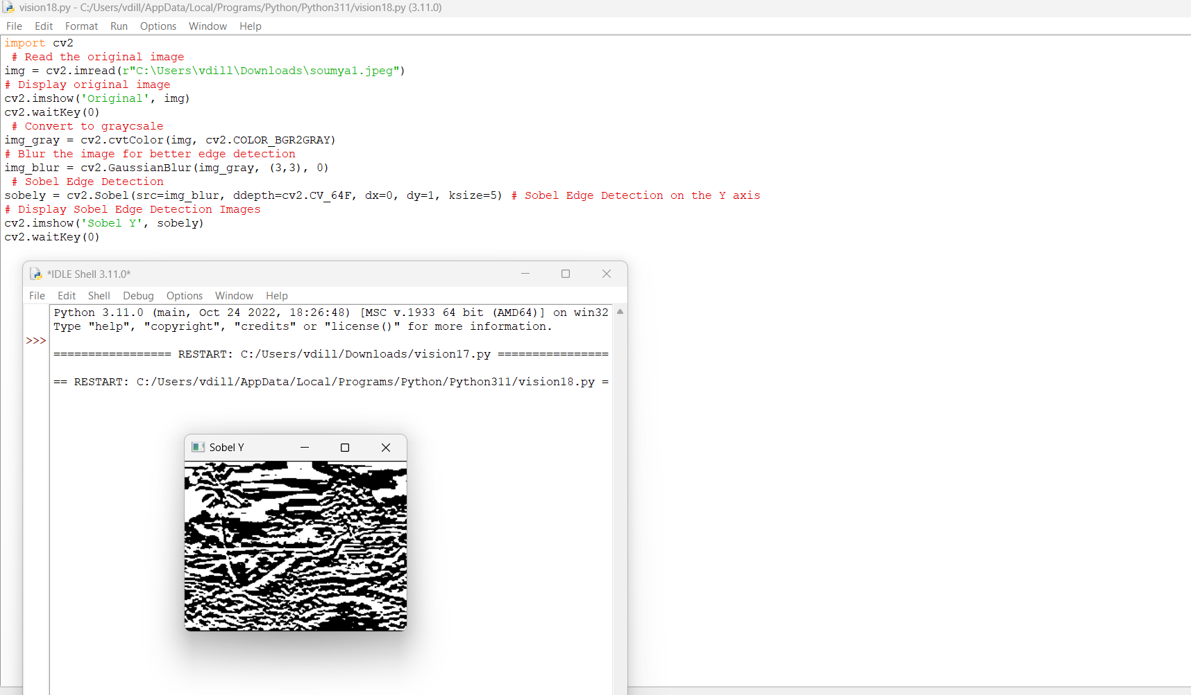

19. Perform Edge detection using Sobel Matrix along XY axis

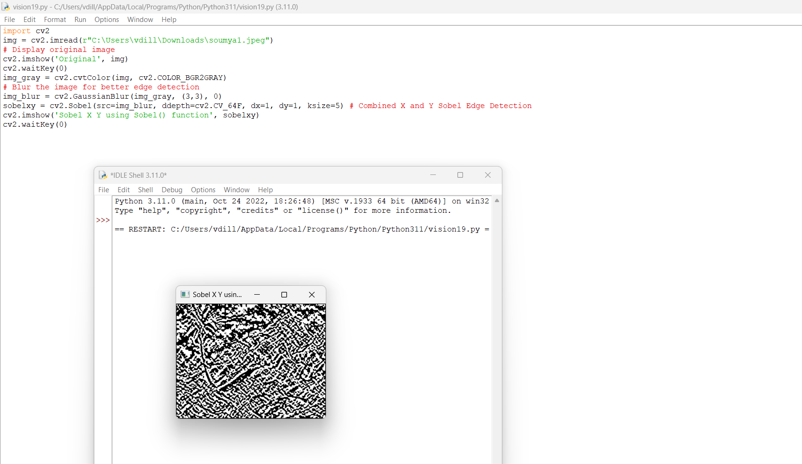

20. Perform Sharpening of the Image using a Laplacian mask with a negative centre coefficient.

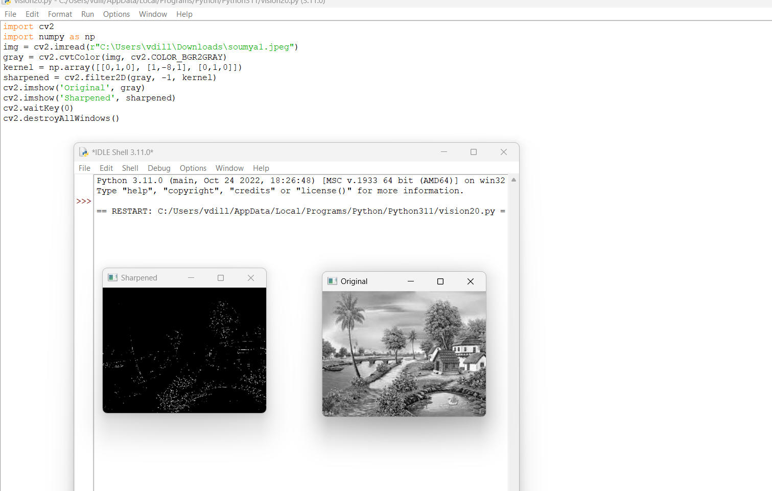

21. Perform Sharpening of the Image using a Laplacian mask implemented with an extension of diagonal neighbours.

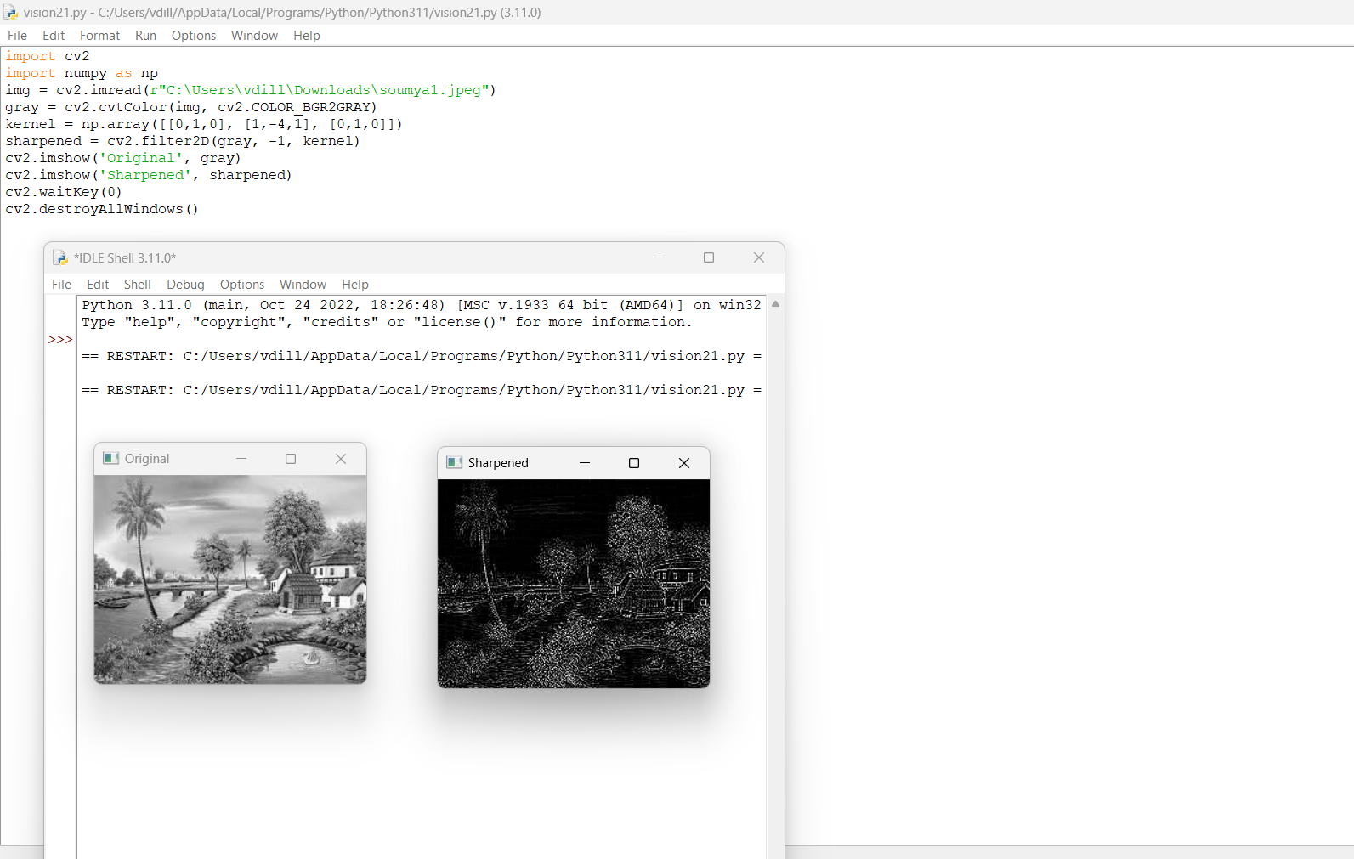

22. Perform Sharpening of the Image using a Laplacian mask with a positive centre coefficient.

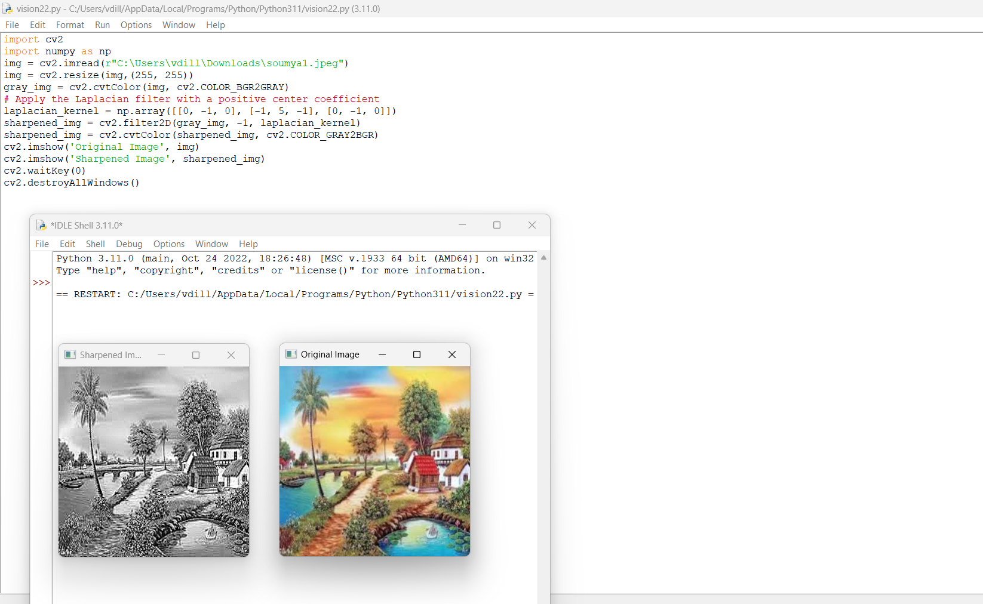

23. Perform Sharpening of the Image using unsharp masking.

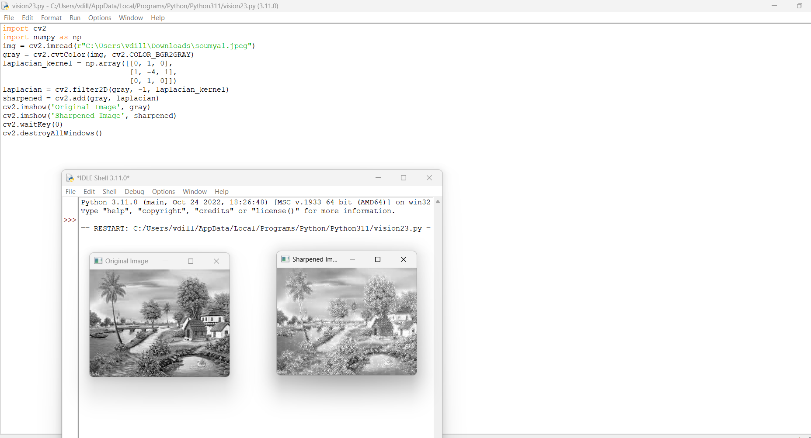

24. Perform Sharpening of Image using High-Boost Masks.

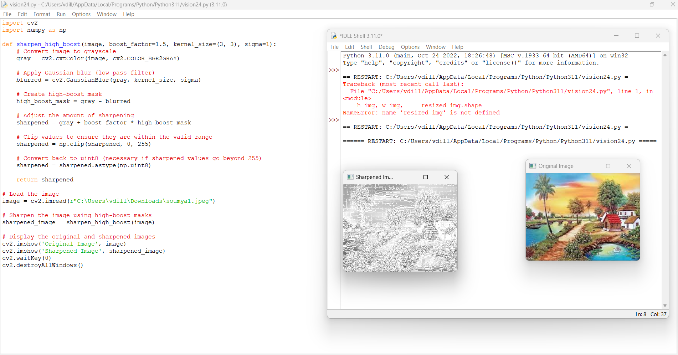

25. Perform Sharpening of Image using Gradient masking.

